II B. Tech II Semester Regular/Supplementary Examinations – May, 2024
DESIGN & ANALYSIS OF ALGORITHMS

(CSE)

Time: 150 Min Max. Marks: 80M

SECTION - A

Answer all Four questions 4×10M=40M

- a) Define the terms Time Complexity and Space Complexity.
b) Design an algorithm for the addition of two matrices and determine the time complexity using the frequency count method.
c) Compute the time complexity of T(n) in terms of θ for the following recurrence relation using the Recurrence Tree Method.
$$T\left(n\right)=7 T\left(\frac{n}{2}\right)+18n^{2}, n>1, \& T\left(1\right)=1, n=1$$
- Let ai, 1 ≤ i ≤ n be a list of elements sorted in a non-decreasing order. Find whether the given element x is present in the list or not. If x is present, determine a value j (element’s position) such that aj=x. If not in the list, then j is set to zero.
- Design a recursive algorithm for the above problem scenario.
- By using recursive algorithm 1(a) search the elements 151, -14, and 9 from the list of elements: 82, -6, 0, 23, 9, 7, 54, -15, 151, 131, 125, 112, 142, 101. Illustrate the traces of three inputs.
- Analyze the recursive algorithm based on the element comparison with best and worst-case time complexities.

- a) What is backtracking? What are the specific areas of its applications?
b) Design the pseudocode/ algorithm for the sum of subsets problem using the backtracking approach.
c) Consider the following sum of subsets problem instance, n=6, m=30, and w= [1:6] = {5, 10, 12, 13, 15, 18}. Find all possible subsets of w that sum to m. Draw the portion of the state space tree that is generated.
d) Analyze the algorithm with best and worst-case time complexities.

- Given an undirected and connected graph G = (V, E), a spanning tree of the graph G is a tree that spans G (that is, it includes every vertex of G) and is a subgraph of G (every edge in the tree belongs to G).
a) Design an algorithm to find the minimum spanning tree for the given graph starting from the vertex S.
b) Draw the minimum spanning tree that would result from running Prim’s algorithm on this graph, starting at vertex s. List the order in which edges are added to the tree.
c) Draw the minimum spanning tree that would result from running Kruskal’s algorithm on this graph. List the order in which edges are added to the tree.
d) Analyze both algorithms in terms of time complexity
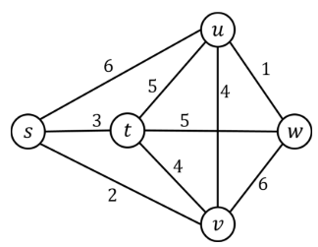

SECTION - B
Answer all Two questions 2×20M=40M

- a) Compare and Contrast Dynamic with the Greedy Approach with necessary example scenarios.
b) Design an iterative algorithm to find the minimal cost of the Optimal Binary Search Tree (OBST).
c) Find the optimal binary search tree for N = 6, having keys k1, k2 ... k6 and weights p1 = 10, p2 = 3, p3 = 9, p4 = 2, p5 = 0, p6 = 10; q0 = 5, q1 = 6, q2 = 4, q3 = 4, q4 = 3, q5 = 8, q6 = 0 by using tabulation method.
d) Analyze the time complexity to obtain an optimal binary search tree.

- a) State P, NP and NP-Complete classes of problems with example scenarios.
b) State Travelling Sales person problem. Design an algorithm for travelling sales person problem to find the minimal path and calculate the minimal route for the cost matrix using Least Cost (LC) branch and bound method.
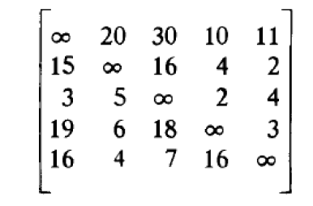
c) Compute time complexity for the above problem (part b).

